01.
class Demo {
public static void main(String args[]){
int tot = 971;
double avg;
avg = (double) tot/10; A. avg = (double) tot/10;
System.out.println("Average : " + avg);

}
}

Output

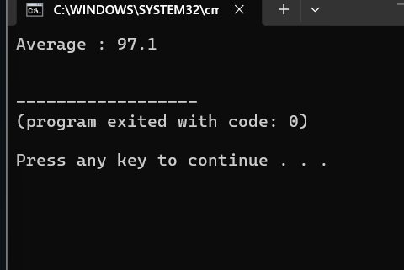

02.
Code.
class Example {
public static void main (String args[]){
double d;
d=5/2+5/2;
System.out.println(d);
d=5/2.0+5/2;
System.out.println(d);
d=5/2+5.0/2;
System.out.println(d);
d=5/2.0+5/2.0;
System.out.println(d);
}
}
output
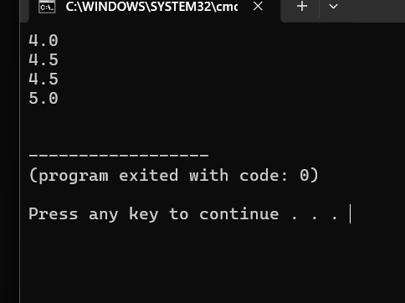
Answer - E
03.
Code.
class Example{
public static void main(String args[]){
int a=10, b=7,c=-10,d=-7;
System.out.println(a%b);
System.out.println(-a%b);
System.out.println(a%-b);
System.out.println(-a%-b);
System.out.println(+a%+b);
System.out.println(c%d);
System.out.println(-c%d);
}
}

Output.
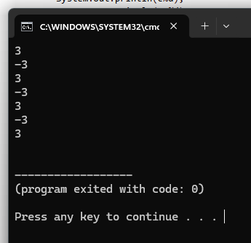

04.
Code.
class Example{
public static void main(String args[]){
int x=10,y=7;
System.out.println(x+y);
System.out.println(-x);
System.out.println(-x-y);
System.out.println(-(x-y));
System.out.println(+y);
System.out.println(+y-x);
}
}

Output
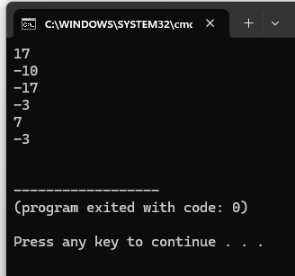

05.
Code.
class Example{
public static void main(String args[]){
int x =-100;
x=+x;
System.out.println(x);
x=-x;
System.out.println(x);
x=-x;
System.out.println(x);
x=x+x;
System.out.println(x);
x=-x-x;
System.out.println(x);
x=x-x;
System.out.println(x);
}
}

Output.
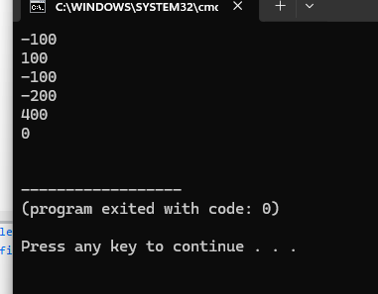

06.
Code.
class Example{
public static void main(String args[]){
int x=100;
System.out.println(x++);
System.out.println(x++);
x++;
System.out.println(++x);
System.out.println(x++);
}
}

Output.
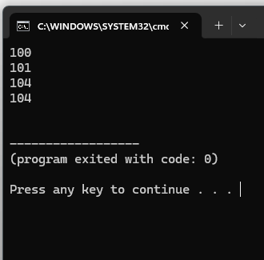

07.
Code.
class Example{
public static void main(String args[]){
int x=100,y;
y=x++;
System.out.println(x+" "+y);
y=x++;
System.out.println(x+" "+y);
y=x++;
System.out.println(x+" "+y);
}
}

Output.
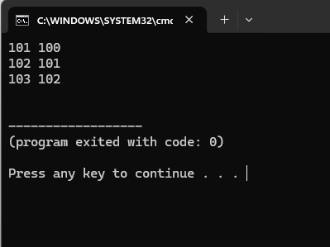

08.
Code.
class Example{
public static void main(String args[]){
int x=100,y;
y=++x;
System.out.println(x+" "+y);
y=++x;
System.out.println(x+" "+y);
y=++x;
System.out.println(x+" "+y);
}
}

Output.
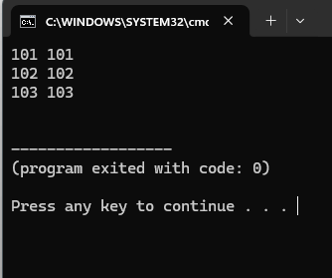

09.
Code.
class Example{
public static void main(String args[]){
int x=100;
x=x++;
System.out.println(x);
x=x++;
System.out.println(x);
x=x++;
System.out.println(x);
x=++x;
System.out.println(x);
x=++x;
System.out.println(x);
x=++x;
System.out.println(x);
}
}

Output.
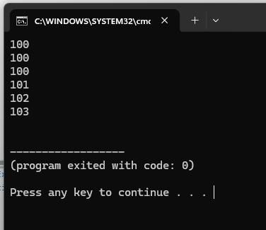
10.
Code.
class Example{
public static void main(String args[]){
int a=10,b=20;
int x;

x= a + b;//a-->10 + 20 = 30
System.out.println(x);
x= a +-b;//b-->10 + -20= -10
System.out.println(x);
x= ++a +b;//c--> 11 + 20 = 31
System.out.println(x);
x= a+ b++;//d--> 11 + 20 = 31
System.out.println(x);
x= ++a + b++;//e--> 12 + 21 = 33
System.out.println(x);
x= a++ + b++;//f--> 12 + 22 = 34
System.out.println(x);
x= ++a + ++b;//g--> 14 + 24 = 38
System.out.println(x);
x= a++ + ++b;//h--> 14 + 25 = 39
System.out.println(x);
}
}
Output.
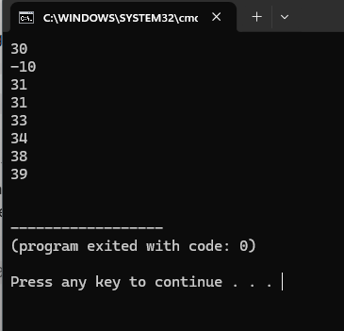
11.
Code.
class Example{
public static void main(String args[]){
int x;
x=12 - 4*2;// line1
System.out.println("12 - 4 * 2: "+x);//
x=(12 - 4)*2;//line2
System.out.println("(12 - 4)* 2: "+x);
x=12 -(4*2);//line3
System.out.println("12 -(4 * 2): "+x);
}
}

Output.
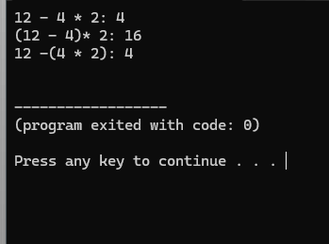
Explain -
Line1 - Multiplication (*) has a higher priority than subtraction (-).
Line2 - parentheses () are always evaluated first
Line3 - The expression inside the parentheses is evaluated first

12.
Code.
class Example {
public static void main(String args[]) {
int x;
x = 7 % 10 / 2 * 2;// line1 % --> / --> * (this is how its work)
System.out.println(x);
x = 7 % (10 / 2) * 2;//line2 (10/2) --> % --> * (this is how its work)
System.out.println(x);
x = 7 % 10 / (2 * 2);//line3 (2*2) --> % --> / (this is how its work)
System.out.println(x);
x = 7 % (10 / (2 * 2));//line4 (2*2) --> (10/4) --> % (this is how its work)
System.out.println(x);
x = 7 % ((10 / 2) * 2);//line5 (10/2) --> (5*2) --> % (this is how its work)
System.out.println(x);
}
}

Output.
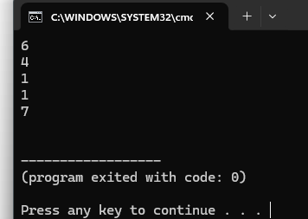
Explain.
Line1 - (7%10=7 -> 7/2=3 -> 3*2=6)
Line2 - (10/2=5 -> 7%5=2 -> 2*2=4)
Line3 - (2*2=4 -> 7%10=7 -> 7/4=1)
Line4 - (2*2=4 -> 10/4=2 -> 7%2=1)
Line5 - (10/2=5 -> 5*2=10 -> 7%10=7)
13.
Code.
import java.util.*;
class Example{
public static void main(String args[]){
Scanner input = new Scanner(System.in);
System.out.print("Enter the dividend : ");
double num1 = input.nextDouble();

System.out.print("Enter the diviser : ");
double num2 = input.nextDouble();

int quontient = (int)num1 / (int)num2;
double remainder = num1 % num2;

System.out.println("Quontient = "+ quontient );
System.out.printf("Remainder = %.2f\n",remainder);

}
}
output.
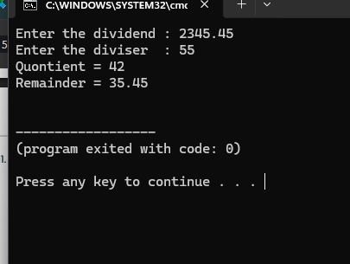

14.
Code.
import java.util.*;
class Example{
public static void main(String args[]){
Scanner input =new Scanner(System.in);
System.out.print("Enter first number : ");
double num1 = input.nextDouble();

System.out.print("enter second number : ");
double num2 = input.nextDouble();

double add = num1 + num2;
double multi = num1*num2;
double sub = num1-num2;
double divi = num1/num2;
double rem = num1 % num2;

System.out.printf("Addition of your two nubers - %.2f\n",add);
System.out.printf("Multiplication of your two nubers - %.2f\n",multi);
System.out.printf("Subtraction of your two nubers - %.2f\n",sub);
System.out.printf("Division of your two nubers - %.2f\n",divi);
System.out.printf("Remainder of your two nubers - %.2f\n",rem);
}
}

Output.
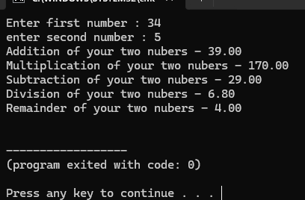
15.
Code.
import java.util.*;
class Example{
public static void main(String args[]){
Scanner input = new Scanner(System.in);
System.out.print("Enter the radius : ");
double radi = input.nextDouble();

double area = 3.14*radi*radi;
double perim = 2*3.14*radi;

System.out.println("area of a circle : "+area );
System.out.println("perimeter of a circle : "+perim);
}
}

Output.
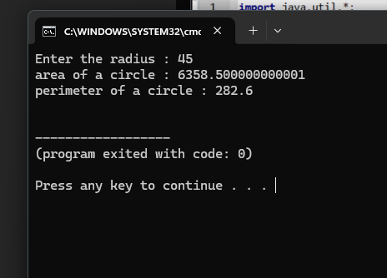

16.
Code.
import java.util.*;
class Example{
public static void main(String args[]){
Scanner input = new Scanner(System.in);
System.out.print("Enter the price of the product : ");
double price = input.nextDouble();

System.out.print("Enter the discount rate(%) of the product : ");
double dis_rate = input.nextDouble();

double discount = price *(dis_rate/100);

System.out.printf("Your discount price : %.2f\n",discount);
}
}

Output.
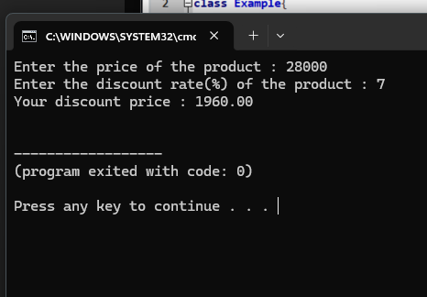

17.
Code.
import java.util.*;
class Example {
public static void main (String args[]){
Scanner input = new Scanner(System.in);
System.out.print("Enter the total amount of purchase : ");
double tot = input.nextDouble();

double tax = tot*0.15;

System.out.printf("Your import tax : %.2f\n",tax);
}
}

Output.
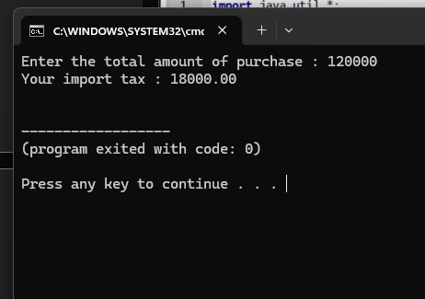

18.
Code.
import java.util.*;
class Example{
public static void main(String args[]){
Scanner input = new Scanner(System.in);
System.out.print("Enter the byte value : ");
long b_val = input.nextLong();//byte value can be more long thats why I put the long

double kb = b_val/1024;
double mb = b_val/(1024*1024);
double gb = b_val/(1024*1024*1024);

System.out.printf("KB value of your byte value : %.2f\n", kb);
System.out.printf("MB value of your byte value : %.2f\n", mb);
System.out.printf("GB value of your byte value : %.2f\n", gb);
}
}

Output.
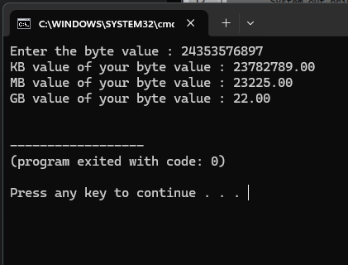

19.
Code.
import java.util.*;
class Example{
public static void main(String args[]){
Scanner input = new Scanner(System.in);
System.out.print("Number of days : ");
int days = input.nextInt();

int months = days/30;
int rDays = days%30;
System.out.println(months+" Mounths and "+rDays+" days");

}
}

Output.
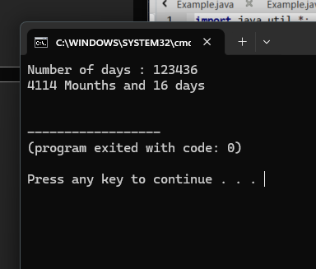

20.
Code.
import java.util.*;
class Example{
public static void main (String args[]){
Scanner input = new Scanner(System.in);
System.out.print("Input Second : ");
int sec = input.nextInt();

int hours = sec/(60*60);
int min = (sec%(60*60))/60;
int fSec = sec%60;

System.out.println(hours+":"+min+":"+fSec);

}
}

Output.
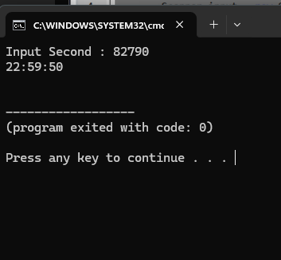

21.
Code.
import java.util.*;
class Example{
public static void main (String args[]){
Scanner input = new Scanner(System.in);
System.out.print("How many eggs do you have: ");
int eggs = input.nextInt();

int gross = eggs / 144;
int rGross = eggs % 144;
int dozens = rGross / 12;
int leftovers = rGross % 12;

System.out.printf("Your number of eggs is %d gross, %d dozen, and %d\n", gross, dozens, leftovers);
}
}

Output.
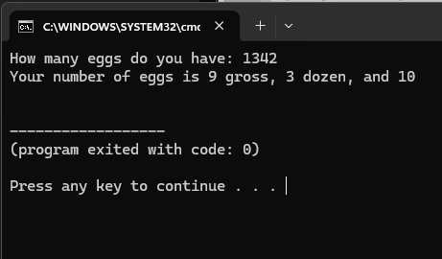

22.
Code.
import java.util.Scanner;
class Example {
public static void main(String[] args) {
Scanner input = new Scanner(System.in);
System.out.print("Enter dividend: ");
int dividend = input.nextInt();

System.out.print("Enter divisor: ");
int divisor = input.nextInt();

int quotient = dividend / divisor;
int remainder = dividend - (divisor * quotient);
System.out.println("Remainder: " + remainder);
input.close();
}
}

Output.
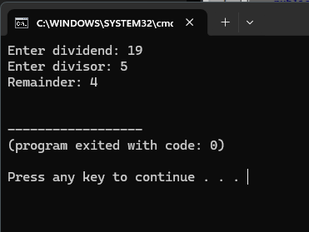

23.
Code.
import java.util.Scanner;
class Example {
public static void main(String[] args) {
Scanner input = new Scanner(System.in);
System.out.print("Input weight in kilograms: ");
double weight = input.nextDouble();

System.out.print("Input height in meters: ");
double height = input.nextDouble();

double bmi = weight / (height * height);

System.out.printf("Body Mass Index is %.2f\n", bmi);

}
}

Output.
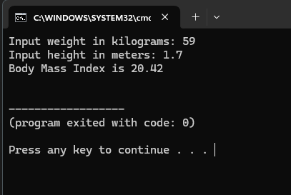

24.
Code.
import java.util.Scanner;
class Example{
public static void main(String[] args) {
Scanner input = new Scanner(System.in);
System.out.print("Enter basic salary: ");
double basicSalary = input.nextDouble();

double employeeFund = basicSalary * 0.120;
double employerFund = basicSalary * 0.035;
double pensionFund = basicSalary * 0.083;

System.out.printf("Employee Fund : %.2f\n", employeeFund);
System.out.printf("Employer Fund : %.2f\n", employerFund);
System.out.printf("Pension Fund : %.2f\n", pensionFund);

}
}

Output.
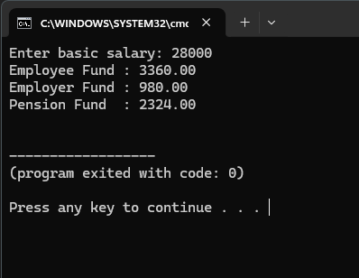

25.
Code.
import java.util.Scanner;
class Example {
public static void main(String[] args) {
Scanner input = new Scanner(System.in);
System.out.print("Enter the tax-inclusive price in dollars: ");
double inclusivePrice = input.nextDouble();

double actualPrice = inclusivePrice / 1.10;
double salesTax = inclusivePrice - actualPrice;

System.out.printf("Actual Price is: $%.2f\n", actualPrice);
System.out.printf("Sales Tax is: $%.2f\n", salesTax);

}
}

Output.
